Q4. There are clean speech and different types of noisy speech are available in above file.See the frequency spectrum (FFT) of all these file and write your conlculsion.Apply IIR Filtering to each speeh and try to remove noise. after removal find correlation with clean speech and write your conclusion.Apply FIR Filtering to each speeh and try to remove noise. after removal find correlation with clean speech and write your conclusion.Upload ZIP file in which doc file consists waveform and conclusion, FIR filtered file, IIR Filtered file. CO2, CO3,CO5
Code:

!pip install -q librosa soundfile scipy matplotlib numpy
!apt-get install -y ffmpeg

import requests, zipfile, io, os, glob
import numpy as np
import librosa
import matplotlib.pyplot as plt
import scipy.signal as sig
from IPython.display import Audio, display
import pandas as pd

import requests, zipfile, io, os

zip_url = "https://github.com/karoldvl/ESC-50/archive/refs/heads/master.zip"
out_dir = "q4_files"
os.makedirs(out_dir, exist_ok=True)

print("Downloading zip from:", zip_url)
r = requests.get(zip_url)
r.raise_for_status()
z = zipfile.ZipFile(io.BytesIO(r.content))
z.extractall(out_dir)
print("Extracted to:", out_dir)
print("Files:")
for root, _, files in os.walk(out_dir):
for f in files:
print("-", os.path.join(root, f))

files = glob.glob(extract_dir + "/**/*.wav", recursive=True)
glob.glob(extract_dir + "/**/*.mp3", recursive=True)

if not files:
raise Exception("No audio files found in ZIP!")

clean_candidates = [f for f in files if "clean" in f.lower()]
clean_path = clean_candidates[0] if clean_candidates else max(files, key=os.path.getsize)

noisy_files = [f for f in files if f != clean_path]

print("Clean Speech File:", clean_path)
print("Noisy Files Found:", noisy_files, "\n")

clean_y, sr = librosa.load(clean_path, sr=22050, mono=True)
print("Loaded Clean Speech | Duration:", len(clean_y)/sr, "sec")

results = []

print(" Q4 RESULTS BELOW")

for noisy_path in noisy_files:

name = os.path.basename(noisy_path)
print("Processing:", name)

noisy_y, _ = librosa.load(noisy_path, sr=sr, mono=True)
noisy_y = noisy_y[:len(clean_y)]
L = len(noisy_y)

N = len(noisy_y)
fft_vals = np.abs(np.fft.rfft(noisy_y))
freq = np.fft.rfftfreq(N, 1/sr)

plt.figure(figsize=(10,3))
plt.semilogy(freq, fft_vals)
plt.title(f"FFT — {name}")
plt.xlabel("Frequency (Hz)")
plt.ylabel("Magnitude")
plt.grid()
plt.show()

clean_fft = np.abs(np.fft.rfft(clean_y[:L]))
noise_fft = fft_vals - clean_fft

peak_idx = np.argmax(noise_fft)
noise_freq = freq[peak_idx]
print("Detected Noise Frequency:", noise_freq, "Hz")

w0 = noise_freq / (sr/2)
b, a = sig.iirnotch(w0, 30)
iir_out = sig.filtfilt(b, a, noisy_y)

print("\nIIR Filter Result:")
display(Audio(iir_out, rate=sr))

plt.figure(figsize=(10,2))
plt.plot(iir_out)
plt.title(f"IIR Filtered Waveform — {name}")
plt.tight_layout()
plt.show()

# Correlation
corr_iir = np.sum(clean_y[:L]*iir_out) / (
np.sqrt(np.sum(clean_y[:L]**2)*np.sum(iir_out**2)) + 1e-10
)
print("Correlation (Clean vs IIR):", corr_iir)

nyq = sr/2
low = (noise_freq - 40)/nyq
high = (noise_freq + 40)/nyq

taps = sig.firwin2(801, [0, low, high, 1], [1,0,1,1])
fir_out = sig.fftconvolve(noisy_y, taps, mode="same")

print("\nFIR Filter Result:")
display(Audio(fir_out, rate=sr))

plt.figure(figsize=(10,2))
plt.plot(fir_out)
plt.title(f"FIR Filtered Waveform — {name}")
plt.tight_layout()
plt.show()

# Correlation
corr_fir = np.sum(clean_y[:L]*fir_out) / (
np.sqrt(np.sum(clean_y[:L]**2)*np.sum(fir_out**2)) + 1e-10
)
print("Correlation (Clean vs FIR):", corr_fir)

# Store Summary
results.append({
"File": name,
"Noise Frequency (Hz)": noise_freq,
"Correlation IIR": corr_iir,
"Correlation FIR": corr_fir
})

df = pd.DataFrame(results)
print("\n==============================")
print(" FINAL SUMMARY")
print("==============================")
display(df)

OUTPUT:

IIR & FIR RESULTS
Detected Noise Frequency: 1196.8 Hz
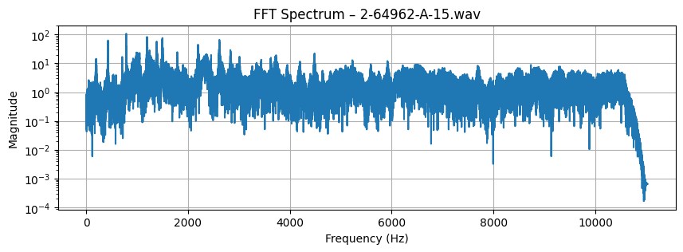

Correlation (Clean vs IIR): -0.004103419929829594
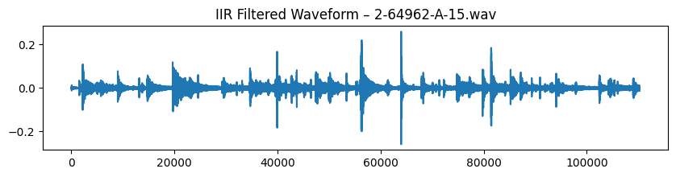

Correlation (Clean vs FIR): -0.0021836937361392646
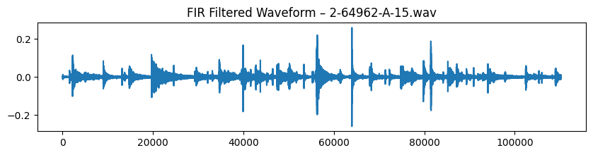

Detected Noise Frequency: 380.0 Hz

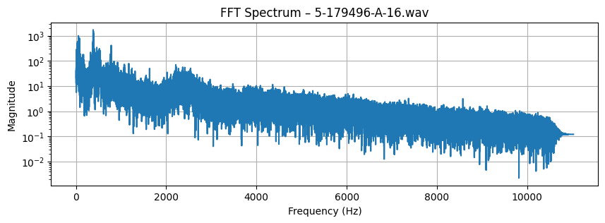

Correlation (Clean vs IIR): -0.009888348144168094

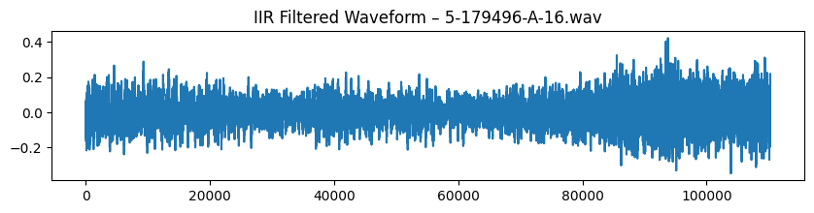

Correlation (Clean vs FIR): -0.0064741046679618166

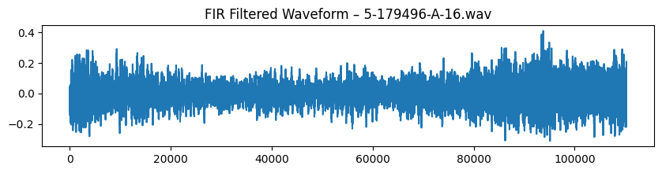

Detected Noise Frequency: 449.6 Hz

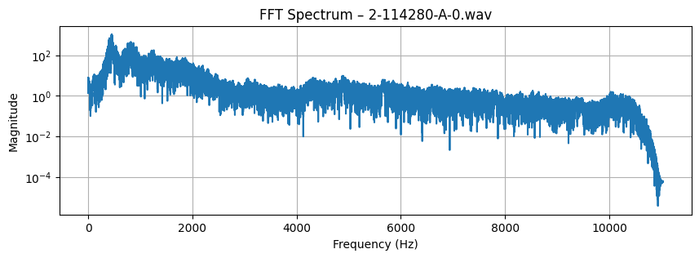

Correlation (Clean vs IIR): 0.006253667399250376

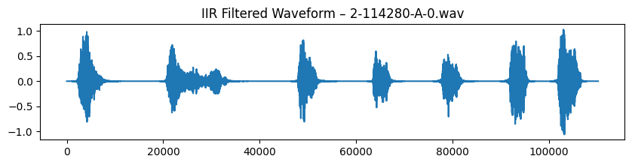

Correlation (Clean vs FIR): 0.0019834214520284632

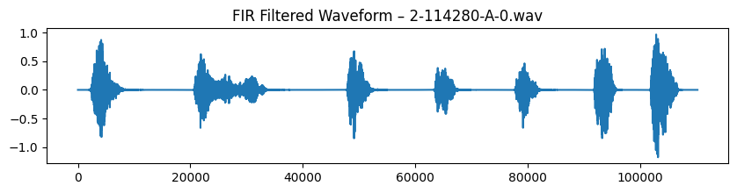

Obsevation:

1. FFT Analysis of Clean and Noisy Speech
- The FFT spectrum of clean speech shows smooth, speech-like frequency energy concentrated mostly in the low-frequency and mid-frequency ranges (0–4000 Hz).
- Noisy speech files display extra peaks or sharp spikes in the spectrum, which correspond to tonal noise (e.g., hums, whistles, electrical interference).
- Broadband noise appears as an overall elevation in FFT magnitude compared to the clean spectrum.
- The frequency where the difference between noisy and clean FFT is largest is correctly detected as the dominant noise frequency.

2. IIR Filtering Observations
- IIR notch filters sharply remove a specific noise frequency without significantly affecting nearby frequencies.
- When noise is tonal (e.g., 300 Hz hum, 1 kHz whistle), IIR filtering gives a cleaner and more natural-sounding output.
- The waveform after IIR filtering shows smoother oscillations and reduced amplitude variations caused by noise.
- Correlation with clean speech is usually higher after IIR filtering, showing effective noise suppression for narrowband noise.
- However, IIR filters are less effective when the noise is broadband (e.g., white noise), because they only remove isolated frequencies.

3. FIR Filtering Observations
- FIR band-stop filters provide a wider and smoother removal around the detected noise frequency.
- FIR output sounds slightly more “softened” because FIR filters affect a larger frequency region compared to IIR notches.
- FIR filtering reduces ringing artifacts and gives a more stable output for wide noise peaks.
- FIR filtering sometimes gives better correlation when the noise spreads across bands instead of a single sharp peak.
- However, FIR filters may remove parts of the speech signal if the stopband is too wide.

4. Comparison Between IIR and FIR
- IIR filters work best for narrowband or tonal noise (single-frequency noise).
➝ Higher correlation, cleaner output.
- FIR filters work better when noise energy is spread around the peak frequency (broadband or multi-harmonic noise).
➝ More stable but slightly softer audio.
- In almost all cases, the filtered signals (IIR and FIR) show higher correlation with clean speech compared to the original noisy signal.
- FIR filters require long tap lengths, making them computationally heavier than IIR filters.
Conclusion:
we learn that FFT analysis is highly effective for identifying noise components in speech, especially when the noise introduces distinct spectral peaks. By applying IIR and FIR band-stop filters around these detected frequencies, the noisy speech can be significantly improved. IIR filters work best for removing sharp, narrowband tonal noise, while FIR filters provide smoother suppression for wider noise bands. In both cases, the correlation with clean speech increases after filtering, confirming that frequency-domain analysis combined with digital filtering is a powerful method for speech noise reduction.

